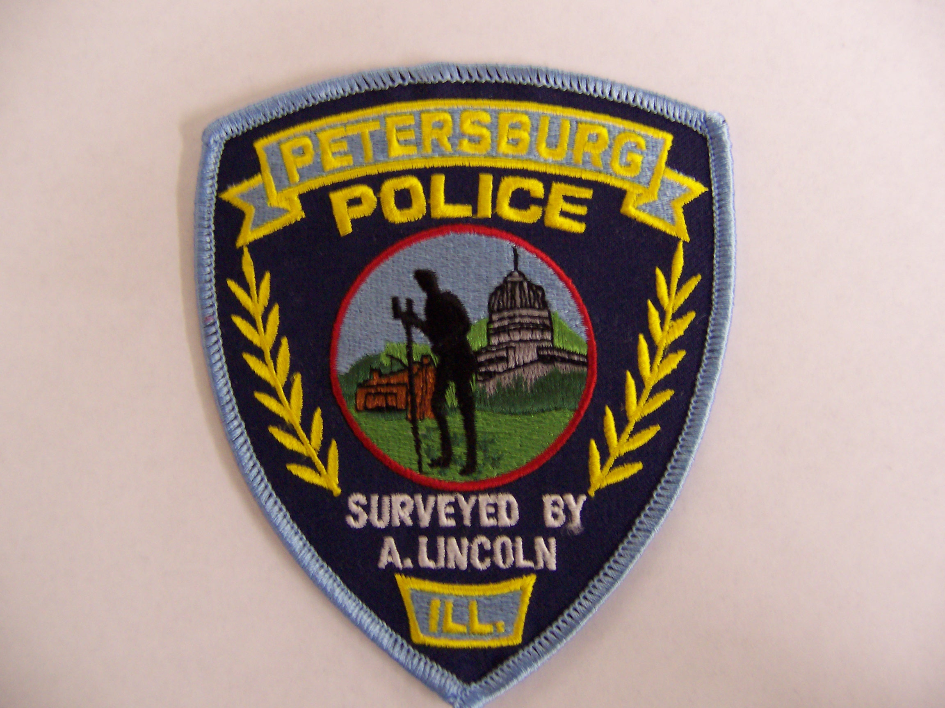
PETERSBURG
POLICE DEPARTMENT
P. O. Box 139, 122 S. Sixth
Petersburg, Illinois 62675
Michael E. Nichols Ph. (217) 632-2251 Fax (217) 632-4324
Chief Assistant Chief
OPPORTUNITY FOR EMPLOYMENT

The City of Petersburg is accepting applications for the positions of Assistant Chief of Police and Full-time Police Officer. Application forms may be downloaded online at www.petersburgil.org or picked up at City Hall, 122 South 6th St Petersburg IL 62675, from 8:00 a.m. – 4:00 p.m., Monday through Friday.
ASSISTANT CHIEF OF POLICE QUALIFICATIONS, EXPERIENCE AND SPECIAL REQUIREMENTS
- Must have at least 5 years of Law Enforcement Experience
- Must have supervisory experience
- Must have worked full-time for a Law Enforcement Agency during the last 3 years

POLICE OFFICER QUALIFICATIONS, EXPERIENCE AND SPECIAL REQUIREMENTS
- Must be 21 years of age
- Have at least a high school diploma or equivalent
- Have a valid Illinois Driver’s License
- Basic Law Enforcement Certification and College education is preferred but not required
- Successfully pass a pre-employment background investigation

Competitive salary and benefits package for full-time officers are set by collective bargaining agreement with the Fraternal Order of Police.
The City of Petersburg offers IMRF retirement, health and dental insurance for full-time employees.

The City of Petersburg is an Equal Opportunity Employer.

