Official Drug Detection Canine
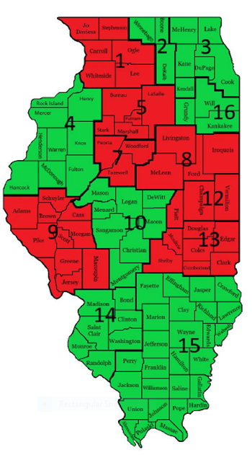
Requalification Program Calendar 2022
January | February | March | April
MTU 3 (20) | MTU 4 (14)  MTU 10 (15) | MTU 2 (15)  MTU 3 (4)  MTU 16 (23)  MTU 14 (19)  MTU 15 (31)  MTU 10 (29) | Cook Co (8)  MTU 13 (14)
May | June | July | August
Cook Co (4)  MTU 2 (6)  MTU 10 (6)  MTU 16 (11)  ISP (11) | MTU 3 (15)  MTU 4 (17)  MTU 3 (9)  MTU 13 (21) | MTU 15 (1)  MTU 14 (9)  Cook Co (14)  Chicago PD (21) | MTU 10 (5)
September | October | November | December
MTU 4 (9)  MTU 14 (17)  MTU 2 (22) | ISP (5)  MTU 3 (6)  MTU 13 (18)  Chicago PD (19)  MTU 15 (27)  MTU 10 (28) | Cook Co (10)  MTU 16 (15) | Chicago PD (15)

