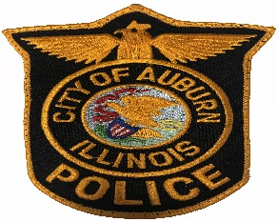

AUBURN POLICE DEPARTMENT
CHIEF DAVE CAMPBELL

324 WEST JEFFERSON STREET
AUBURN, ILLINOIS 62615
PHONE (217) 438-3351
FAX (217) 438-3724
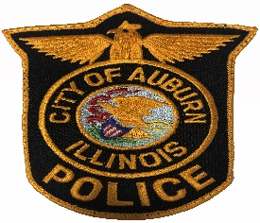

The Auburn Police Department will be accepting applications for full time police officers. The city offers medical, eye and dental insurance, and IMRF retirement plan.

MINIMUM QUALIFICATIONS

- Be certified minimum as a part time officer with the ILETSB.
- High School Diploma or GED
- Age 21 and over
- Must have valid Illinois driver’s license
- Must successfully complete a background investigation.
- No felony convictions. Certain misdemeanor convictions may disqualify candidates for a position with the department.
- Lateral hires up to 3yrs.

DEADLINE FOR APPLICATIONS

Open

Applications can be found at https://auburnillinois.us or picked up at 324 West Jefferson Auburn, IL
Between the hours of 8 am – 4 pm.

The City of Auburn is an equal opportunity employer.

